**6G4Z0016 Databases**

**Introduction to MariaDB Databases and SQL**

**Part 2: Converting a simple ERD into a database**

**Aim**

The aim of this session is to be able to:

* Implement database tables from an ERD
* Use Primary and Foreign Key Constraints in table creation
* Apply a check, not null and unique constraint
* Insert Data
* Do some basic queries

**Activities**

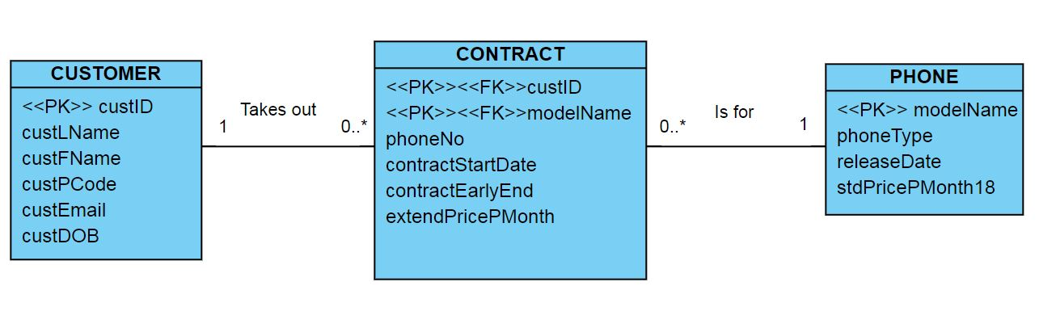

**Figure 1. Simple ERD for customer management of phone contracts**

1. Use the ERD in Figure 1 to create the tables in MariaDB in the following order. Although you may wish to create one table at a time, you should write a script that includes the creation statements for ALL the tables.
   1. CUSTOMER
   2. PHONE
   3. CONTRACT

All tables should be created in one sql script file. When you have created your tables save the file as phone.sql. (Make sure that you do not overwrite this script file with your next SQL statements!!!) Then add the following lines to the code at the top.

DROP TABLE IF EXISTS CONTRACT;

DROP TABLE IF EXISTS PHONE;

DROP TABLE IF EXISTS CUSTOMER;

**Note:** In the database there will be 5 types of phone { ‘BUDGET’, ‘HIGH_END’,’CAMERA’, ‘KIDS’, ‘SENIOR’} and the maximum price per month for an 18 month contract is (stdPricePMonth18) is 55.99. (Currently only 18 month contracts are offered.) contractStartDate is the date the contract started. contractEarlyEnd indicates whether the customer has ended the contract early and is a simple ‘Y’ or ‘N’ Boolean indicator. contractEarlyEnd has a default of N. extendPricePMonth is the cost charged per month after the contract ends. This defaults to 55.99 for all phones unless an alternative deal is agreed with the customer (it’s a good revenue generator!).

1. **Populate the database using the data below.** When entering the data, watch to ensure that all your constraints work.

**CUSTOMER**

|  |  |  |
| --- | --- | --- |
| custID | 100000001 | 100000002 |
| custLName | Potter | Disney |
| custFName | Harry | Mickey |
| custPCode | Z12 XZY | MK7 FY6 |
| custEmail | [H.Potter@btinternet.com](mailto:H.Potter@btinternet.com) | M.Disney@wdw.com |
| custDOB | 12/12/97 | 25/12/82 |

**PHONE**

|  |  |  |  |  |
| --- | --- | --- | --- | --- |
| modelName | Iphone XA | Samsung SD | Haiwei YH | Vodaphone PD |
| phoneType | HIGH_END | CAMERA | BUDGET | SENIOR |
| releaseDate | 01/Jan/21 | 01/Nov/20 | 10/Jan/21 | 01/Feb/21 |
| stdPricePMonth18 | £55.99 | £35.99 | £12.99 | £57.99 |

**CONTRACT**

|  |  |  |  |  |
| --- | --- | --- | --- | --- |
| custID | 100000001 | 100000002 | 100000001 | 100000002 |
| modelName | iphone XA | Samsung SD | Haiwei YH | Iphone XA |
| phoneNo | 07745567287 | 07756765245 | 07765725937 | 07726674538 |
| contractStartDate | 02/Feb/21 | 30/Jan/21 | 22/Feb/21 | 05/feb/21 |
| contractEarlyEnd | N | N | N | N |
| extendPricePMonth | 55.99 | 55.99 | 55.99 | 55.99 |

Make a note of what data fails to insert and why.

1. Discuss the major weakness of this database design.